2) assignment
2)we have git repository 2026Q1 in that index.html file present. this is private repository . on jenkin master server httpd is installed. you need to create job like you need pull index.html file from repository and deploy on jenkin master server apache httpd.
Ans_-

I have launch ec2 with jenkin by using below steps
2nd menthod ---- here jenkin home directory is diffrent /root/.jenkins/
install java and tomcat deploy war file.
1)luanch ec2 instance -
yum list java-17-amazon*
2) install java ----- yum install java-17-amazon
3) create folder in /mnt ----- mkdir /mnt/servers
4) install tomcat 10 ---- wget https://dlcdn.apache.org/tomcat/tomcat-10/v10.1.53/bin/apache-tomcat-10.1.53.zip
5)unzip apache-tomcat-10.1.53.zip
6)rm -rf apache-tomcat-10.1.53.zip
7) chmod -R 777 apache-tomcat-10.1.53
8) cd apache-tomcat-10.1.53
9) cd webapps/
10)go to link and select latest Jenkins WAR file --- https://www.jenkins.io/doc/book/installing/war-file/
11)select past release option https://get.jenkins.io/war-stable/
12 select latest --> select jenkins.war file option.
13)wget https://get.jenkins.io/war-stable/latest/jenkins.war
14) cd ../
15) cd bin
16) ./startup.sh
17) cd ../
18) cd logs/
19) tail -100f catalina.out

After that I installed httpd and git on ec2
Yum install httpd

- Created • Private Git repository: 2026Q1
• File: index.html

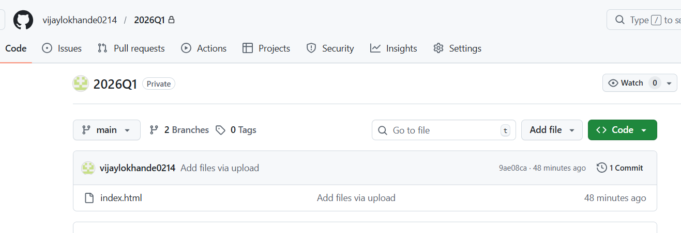
In Jenkins created freestyle job with below configuration

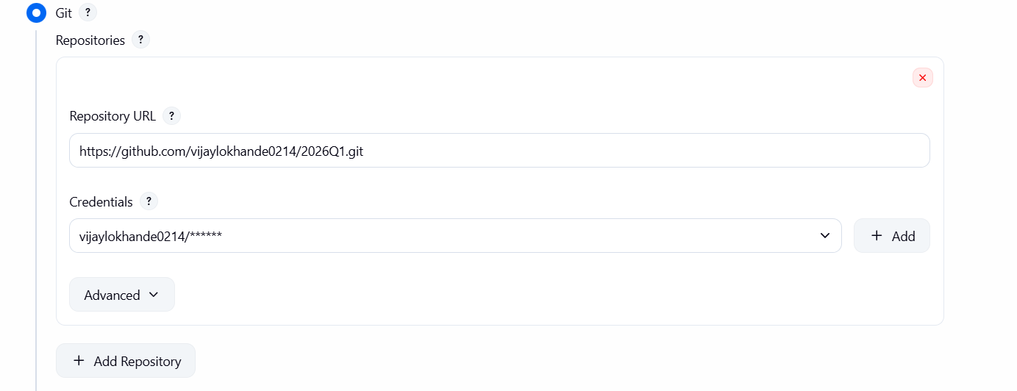
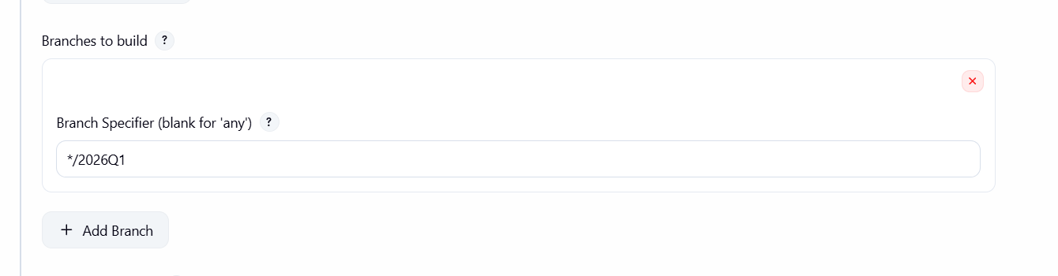
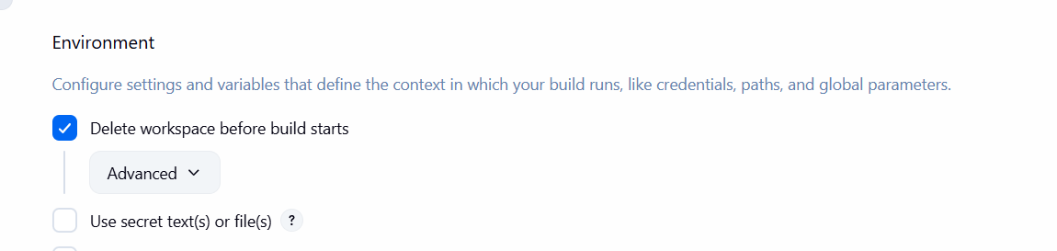
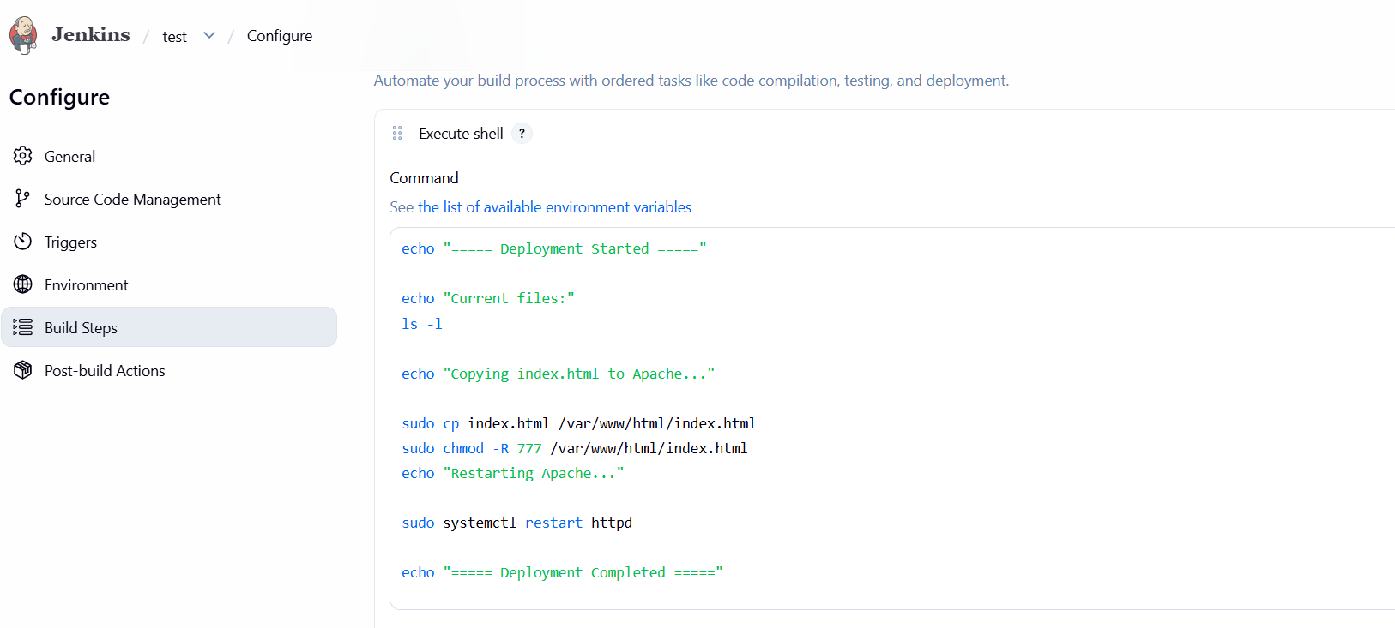
Run job and output
